1. Set up the Folder in this order.

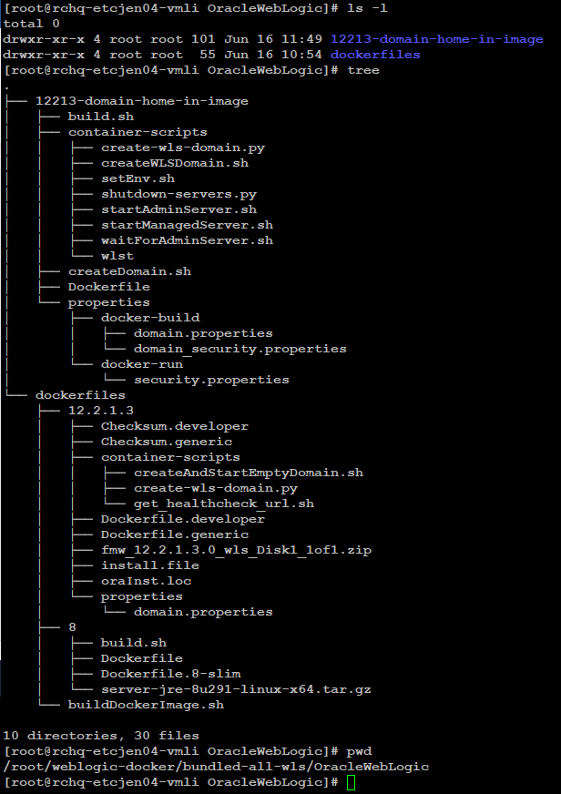

1. Inside the Dockerfile, we will have these sub-folders. Folder 8 is for the java8 we are using and the 12.2.1.3 will get us the necessary element to get the weblogic GUI.

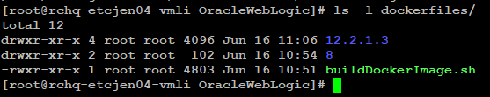

1. We then cd to 8/ and then execute the build.sh script. We also need to place the java binaries too under this folder as we can see in the screenshot.

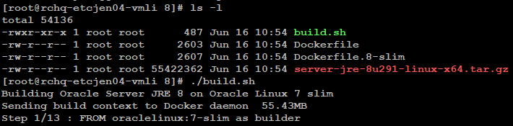

1. We then go back to dockerfile folder and execute the buildDockerimage.sh script. Here I am using [root@rchq-etcjen04-vmli dockerfiles]# ./buildDockerImage.sh -v 12.2.1.3 -g -s

We need to define which weblogic version we are using and if it’s a generic or the Developer one. In this case, I am using 12.2.1.3 version of Weblogic and I am using generic. The folder structure of 12.2.1 3 looks like this if you are curious.

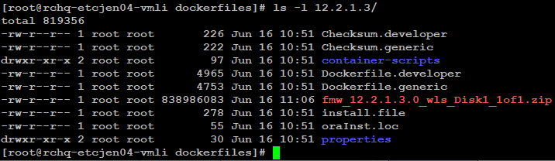

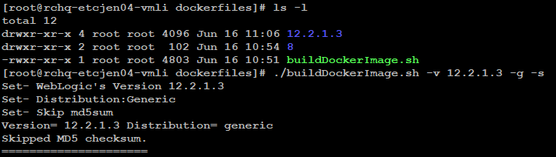

1. We will then end up creating the image of weblogic like this.

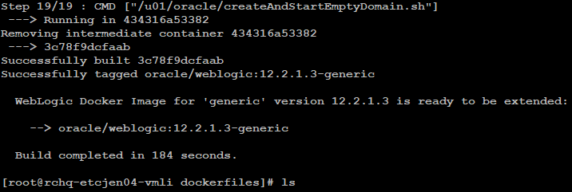

1. We then cd into 12213-domain-home-in-image folder. This folder basically contains all the Domains we need to create, all the Managed Server/Applications we need to configure, all the DataSources and JMSQueue we need.

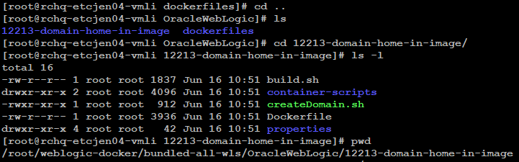

1. We then execute the createDomain.sh Script.

[root@rchq-etcjen04-vmli 12213-domain-home-in-image]# ./createDomain.sh

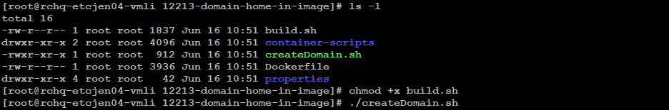

1. If everything went smoothly, we will see something like this

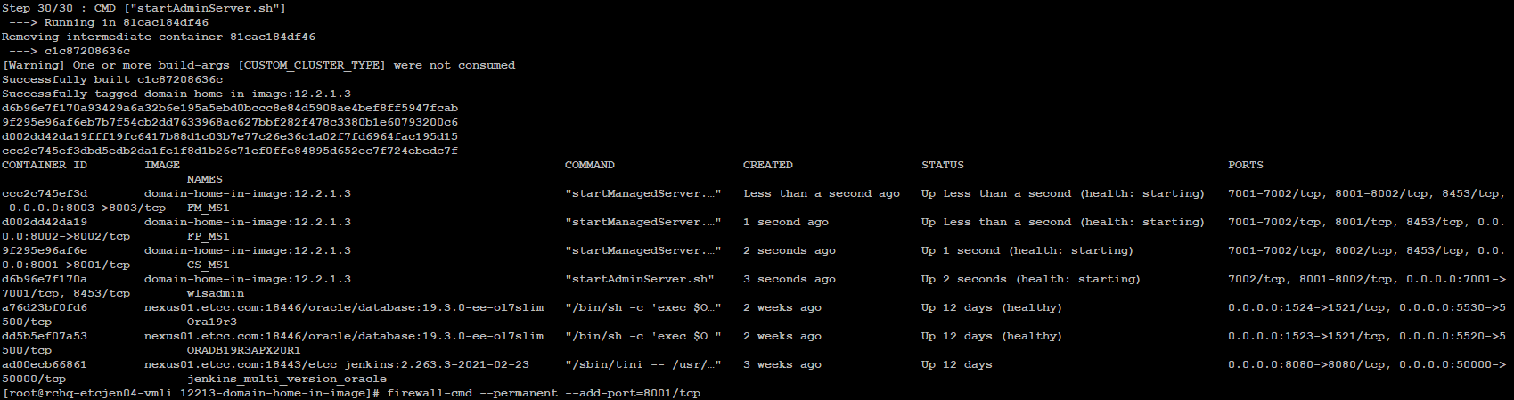

1. We then go to http://<hostname>:7001/console and verify below.

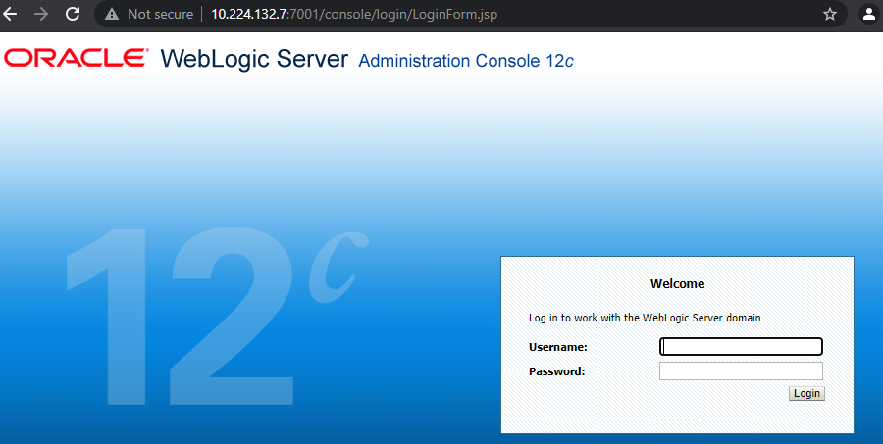

1. Once we log in, we should be able to see admin server and managed servers all up and running. Here I have created a Domain of 3 managed servers only. But we can change those as per our requirements.

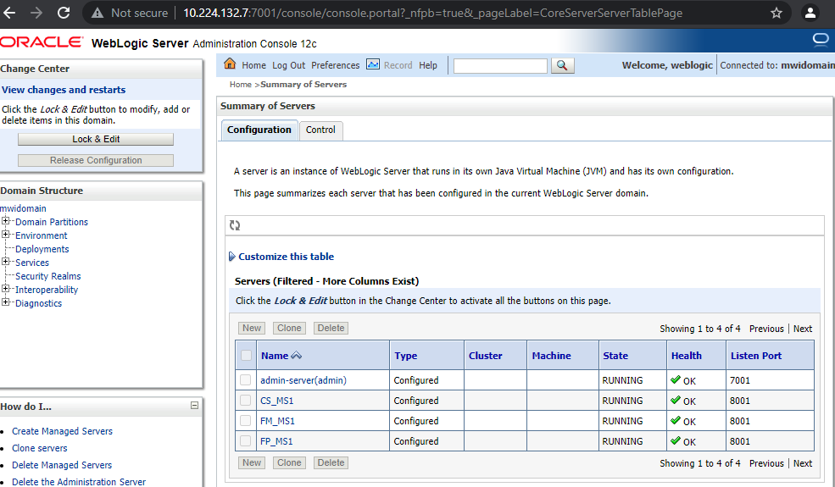

1. For JDBC, I have targeted my Datasource to CS_MS1 in this setup. We can set this as per we need However from OracleWebLogic/12213-domain-home-in-image/container-scripts/create-wls-domain.py

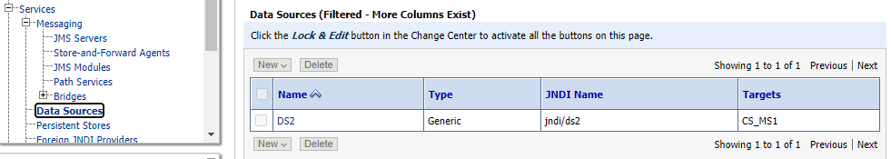

1. I have then created JMS Server that is targeted to FP_MS1.

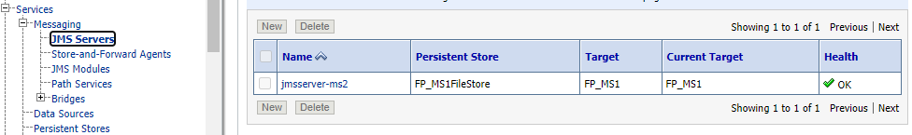

1. I have automated the persistent store that’s required for JMS as well.

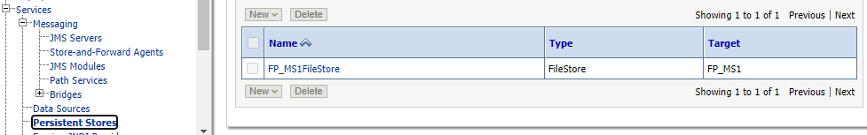

1. The JMS Module and the JMSQueue has also been created and is targeted for FP_MS1.

